NAME: VIDULA R COURSE CODE: CSA1013
REG. NO: 192511270 COURSE NAME: SOFTWARE ENGINEERING

CO1 ASSESSMENT TOOL-2

TITLE: AI-Powered Smart Wastewater Treatment Monitoring System

AGILE SPRINT PLANNING & USER STORY WORKSHOP

1. Project Vision and Stakeholders
1.1 Project Vision
Wastewater treatment plants play a vital role in protecting public health and the environment. However, conventional wastewater monitoring methods often depend on periodic manual sampling and laboratory analysis. This can result in delays in identifying contamination, abnormal water-quality conditions, and equipment failures. The proposed AI-Powered Smart Wastewater Treatment Monitoring System aims to overcome these limitations by combining IoT sensors, Artificial Intelligence, Cloud Computing, and Data Analytics.
The vision of this project is to develop an intelligent and automated platform capable of continuously monitoring wastewater quality and treatment plant equipment. The system will collect real-time sensor data, identify abnormal conditions, predict treatment efficiency, provide maintenance alerts, and recommend suitable corrective actions. By providing timely and accurate information, the system will support plant operators and managers in making better decisions, improving treatment efficiency, reducing operational costs, and maintaining environmental compliance.
The overall vision of the project can be summarized as follows:
To develop a smart, real-time, and AI-powered wastewater monitoring platform that enables treatment plants to detect problems early, optimize operations, predict equipment failures, and support sustainable and environmentally compliant plant operations.

1.2 Project Objectives
The main objectives of the proposed system are to continuously monitor wastewater quality using IoT sensors, detect contamination and abnormal conditions using AI, predict treatment plant performance, monitor equipment health, and provide predictive maintenance alerts. The system will also generate automated compliance reports and provide corrective action recommendations to improve treatment processes.

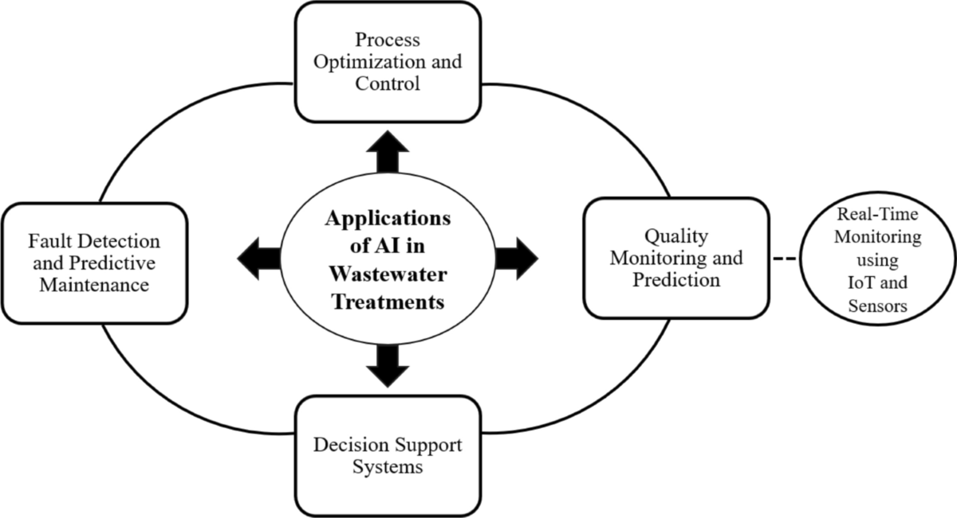
Fig.1 Applications of AI in Wastewater Treatments

The key objectives are:
- Continuous monitoring of wastewater quality.
- AI-based detection of contamination and abnormal conditions.
- Prediction of treatment efficiency.
- Monitoring of treatment equipment performance.
- Prediction of equipment maintenance requirements.
- Generation of automated compliance reports.
- Recommendation of corrective actions.
- Reduction of operational and maintenance costs.
1.3 Stakeholders
The successful development and operation of the system involve several stakeholders. Plant operators are the primary users because they continuously monitor wastewater conditions and respond to system alerts. Plant managers use the system to evaluate treatment efficiency, operational performance, and resource utilization. Maintenance staff depend on equipment monitoring and predictive maintenance alerts to identify potential failures before they result in breakdowns.
Environmental regulators are also important stakeholders because they require accurate monitoring records and compliance reports. Plant owners and management are interested in reducing operating costs, improving efficiency, and ensuring sustainable plant operation. IT administrators are responsible for maintaining the system infrastructure, security, and user access, while data analysts and AI engineers are involved in developing and improving the prediction models.
Stakeholder | Main Role and Interest
Plant Operators | Monitor real-time wastewater conditions and respond to alerts
Plant Managers | Evaluate treatment efficiency and overall plant performance
Maintenance Staff | Monitor equipment health and perform predictive maintenance
Environmental Regulators | Verify compliance with environmental standards
Plant Owners/Management | Reduce costs and improve operational efficiency
AI Engineers/Data Analysts | Develop and improve AI prediction models
IT Administrators | Maintain system infrastructure and security
Sensor and Equipment Suppliers | Provide monitoring hardware and integration support
Local Community | Benefit from reduced pollution and improved environmental safety

2. Creation of Epics and User Stories
The requirements of the system are divided into major functional areas called Epics. Each Epic represents a broad area of system functionality. These Epics are further divided into User Stories that describe the system requirements from the perspective of different users.
Epic 1: Real-Time Wastewater Quality Monitoring
This Epic focuses on continuously collecting and displaying important wastewater parameters such as pH, turbidity, dissolved oxygen, temperature, and chemical oxygen demand. Real-time monitoring is the foundation of the proposed system because it enables the plant operators to observe the current condition of the treatment process without depending entirely on periodic manual sampling.
User Story 1: As a plant operator, I want to view real-time wastewater quality parameters, so that I can continuously monitor the treatment process.
User Story 2: As a plant operator, I want the system to collect sensor data automatically, so that manual sampling and data entry can be reduced.
User Story 3: As a plant manager, I want to view historical water-quality trends, so that I can analyze changes in treatment performance over time.
Epic 2: AI-Based Anomaly and Contamination Detection
This Epic focuses on using Artificial Intelligence to identify unusual patterns in wastewater data. The system will compare current and historical data to identify possible contamination or abnormal operating conditions. Early detection will allow plant operators to take corrective action before the problem becomes more serious.
User Story 4: As a plant operator, I want the system to detect abnormal wastewater conditions using AI, so that I can take corrective action quickly.
User Story 5: As a plant operator, I want to receive alerts when water-quality values exceed acceptable limits, so that potential contamination can be addressed immediately.
User Story 6: As a plant manager, I want to view the history of detected abnormalities, so that I can identify recurring wastewater problems.
Epic 3: Treatment Performance Prediction
This Epic focuses on predicting the future performance of the wastewater treatment process using historical and real-time data. The predictions can help managers understand whether the treatment process is operating efficiently and take action when performance is expected to decline.
User Story 7: As a plant manager, I want the system to predict treatment efficiency, so that I can improve wastewater treatment operations.
User Story 8: As a plant operator, I want to view AI-based treatment performance predictions, so that I can make informed operational decisions.
Epic 4: Equipment Monitoring and Predictive Maintenance
Wastewater treatment plants depend on equipment such as pumps, motors, aerators, and other mechanical systems. Equipment failure can interrupt plant operations and increase maintenance costs. This Epic focuses on monitoring equipment performance and predicting possible failures.
User Story 9: As maintenance staff, I want to monitor equipment performance, so that I can identify abnormal equipment behavior.
User Story 10: As maintenance staff, I want the system to predict possible equipment failures, so that maintenance can be performed before breakdowns occur.
User Story 11: As a maintenance manager, I want to receive maintenance alerts, so that equipment downtime can be reduced.
Epic 5: Corrective Action and Treatment Process Optimization
This Epic focuses on supporting plant operators when abnormal conditions are identified. Instead of only generating an alert, the system can provide recommendations based on the detected condition and historical data.
User Story 12: As a plant operator, I want to receive AI-based corrective action recommendations, so that I can respond effectively to abnormal conditions.
User Story 13: As a plant manager, I want to identify treatment process improvement opportunities, so that operational efficiency can be increased.
Epic 6: Automated Compliance Reporting
Wastewater treatment plants are required to maintain monitoring records and prepare reports for regulatory purposes. This Epic focuses on automatically generating reports using the data collected by the system.
User Story 14: As an environmental compliance officer, I want the system to generate automated compliance reports, so that regulatory reporting time can be reduced.
User Story 15: As a plant manager, I want to access historical monitoring records, so that compliance information can be verified when required.

3. Acceptance Criteria
Acceptance criteria define the conditions that must be satisfied for a User Story to be considered complete. The Given–When–Then format is used because it provides clear and measurable conditions for testing the functionality.
User Story: Real-Time Wastewater Quality Monitoring
As a plant operator, I want to view real-time wastewater quality parameters, so that I can continuously monitor the treatment process.
Condition | Acceptance Criteria
Given | The wastewater sensors are connected and transmitting data
When | New sensor readings are received
Then | The latest values of pH, turbidity, dissolved oxygen, and other parameters are displayed on the dashboard
If a sensor stops transmitting data, the system should identify the missing data and display a warning to the operator. The dashboard should also indicate the time of the most recent successful reading.
User Story: Automatic Sensor Data Collection
As a plant operator, I want the system to collect sensor data automatically, so that manual sampling and data entry can be reduced.
The system must automatically receive sensor readings when the sensors are connected. Each reading should be validated and stored with the parameter name, measured value, date, and time. If invalid or incomplete data is received, the system should identify the problem and prevent incorrect information from being used in analysis.
User Story: AI-Based Anomaly Detection
As a plant operator, I want the system to detect abnormal wastewater conditions using AI, so that I can take corrective action quickly.
When the system receives sufficient wastewater quality data, the AI model should analyze the data and identify unusual patterns. If an abnormal condition is detected, the system should display the affected parameter, the detected condition, and its severity. The result should be visible to the plant operator through the monitoring interface.
User Story: Water-Quality Alerts
As a plant operator, I want to receive alerts when water-quality values exceed acceptable limits, so that potential contamination can be addressed immediately.
If a monitored wastewater parameter exceeds its predefined acceptable limit, the system should automatically generate an alert. The alert should identify the parameter, measured value, time of occurrence, and severity of the condition. The alert should remain available for review until the operator acknowledges or resolves the condition.
User Story: Predictive Maintenance
As maintenance staff, I want the system to predict possible equipment failures, so that maintenance can be performed before breakdowns occur.
When historical and current equipment performance data is available, the AI model should analyze the data for failure patterns. If a possible failure is predicted, the system should generate a maintenance alert containing the equipment name, predicted problem, and risk level.
User Story: Automated Compliance Reports
As an environmental compliance officer, I want the system to generate automated compliance reports, so that regulatory reporting time can be reduced.
When monitoring data is available for a selected time period, the system should generate a report containing the required wastewater quality information, abnormal events, and relevant monitoring records. The report should be available for viewing and downloading by authorized users.

4. Product Backlog Prioritization
The Product Backlog contains all the features and requirements planned for the system. The backlog is prioritized according to business value, user importance, technical dependencies, risk, and the importance of each feature to the core monitoring process.
The MoSCoW prioritization technique is used to categorize the backlog into Must Have, Should Have, Could Have, and Won't Have in the current development phase.
Priority | Backlog Item | Category | Reason
1 | Automatic sensor data collection | Must Have | Foundation for the entire monitoring system
2 | Real-time monitoring dashboard | Must Have | Required for plant operators
3 | Sensor data storage | Must Have | Required for historical analysis and AI
4 | Water-quality threshold alerts | Must Have | Enables early response to abnormal conditions
5 | AI-based anomaly detection | Must Have | Core intelligent feature
6 | Equipment performance monitoring | Should Have | Supports maintenance management
7 | Treatment efficiency prediction | Should Have | Improves operational planning
8 | Predictive maintenance alerts | Should Have | Reduces unexpected equipment failure
9 | Automated compliance reporting | Should Have | Reduces manual reporting effort
10 | AI corrective action recommendations | Could Have | Improves decision support
11 | Advanced treatment optimization | Could Have | Supports future improvements
12 | Fully automated treatment control | Won't Have Now | Requires advanced validation and safety controls
The first Sprint focuses on the basic monitoring foundation because the later AI and predictive features depend on reliable sensor data and a functional data storage system.

5. Sprint Backlog Planning
Sprint Duration
The first Sprint is planned for two weeks. The primary objective of this Sprint is to develop the basic monitoring foundation of the system.
The selected User Stories are:
- Automatic sensor data collection.
- Real-time wastewater monitoring dashboard.
- Historical sensor data storage.
- Water-quality threshold alerts.
These stories have been selected because they have high business value and form the technical foundation for future AI-based features.
Sprint Development Tasks
Automatic Sensor Data Collection
The development team will first identify the required wastewater parameters and define the format of sensor data. The sensor data collection component will then be developed to receive and validate readings. Testing will be performed to confirm that valid sensor data can be received correctly.
Real-Time Monitoring Dashboard
A dashboard will be designed to display the most important wastewater parameters. The interface will show current values and their status. The dashboard will also be connected to the data collection component so that the displayed values are updated when new sensor readings are received.
Historical Data Storage
A database structure will be created to store sensor readings. Each reading will contain the parameter name, value, date, and time. The system will also provide the ability to retrieve historical readings for future analysis.
Water-Quality Alerts
Acceptable thresholds will be defined for the monitored parameters. The system will compare new sensor readings with these thresholds and generate alerts when abnormal values are detected. The alert will be displayed on the dashboard with appropriate information about the detected condition.

6. Effort Estimation Using Story Points
The Fibonacci sequence is used for estimating the relative effort of each User Story. The selected values are 1, 2, 3, 5, 8, and 13. Story Points consider the complexity of development, testing effort, technical uncertainty, and dependencies.
User Story | Story Points | Justification
Automatic sensor data collection | 5 | Requires data input, validation, and communication handling
Real-time monitoring dashboard | 5 | Requires interface design and real-time data display
Historical data storage | 3 | Requires database creation and data retrieval
Water-quality alerts | 3 | Requires threshold comparison and alert logic
Total Estimated Effort: 16 Story Points
The sensor data collection feature is assigned 5 points because it involves data communication, validation, and technical integration. The real-time dashboard is also assigned 5 points because it requires user interface development and continuous data updates. Historical data storage is assigned 3 points because the database structure and retrieval process have moderate complexity. The alert feature is assigned 3 points because it mainly involves threshold comparison and notification logic.
The total effort for Sprint 1 is therefore estimated at 16 Story Points.

7. Sprint Goal and Expected Deliverables
Sprint Goal
To develop the basic monitoring foundation of the AI-Powered Smart Wastewater Treatment Monitoring System by collecting, storing, and displaying real-time wastewater sensor data while generating alerts for abnormal water-quality conditions.
At the end of Sprint 1, the team is expected to deliver a functional initial version of the monitoring system. The system should be capable of receiving wastewater quality data from sensors, validating and storing the data, and displaying the latest values through a monitoring dashboard.
The system should also be able to compare sensor readings against predefined thresholds and generate alerts when abnormal conditions are detected. This Sprint will establish the foundation required for the development of future AI-based anomaly detection, treatment efficiency prediction, and predictive maintenance features.
Expected Sprint Deliverables
- A working sensor data collection component.
- A database for storing wastewater monitoring data.
- A real-time monitoring dashboard.
- A basic water-quality threshold alert system.
- Tested functionality satisfying the defined acceptance criteria.

Definition of Done
A User Story will be considered complete only when the required functionality has been developed, tested, and integrated into the working system. The acceptance criteria must be satisfied, and no critical errors should remain.
The Definition of Done for Sprint 1 includes:
- The required functionality is implemented.
- Sensor data is successfully collected and validated.
- Data is stored correctly with appropriate timestamps.
- Dashboard values are displayed correctly.
- Alerts are generated for abnormal conditions.
- The implemented features have been tested.
- Acceptance criteria are satisfied.
- No critical defects remain in the completed features.

Conclusion
The Agile Sprint Planning and User Story Workshop provides a structured approach for developing the AI-Powered Smart Wastewater Treatment Monitoring System incrementally. The project vision focuses on improving wastewater treatment operations through continuous monitoring, AI-based analysis, predictive maintenance, treatment performance prediction, and automated compliance reporting.
The overall requirements were divided into several Epics, including real-time monitoring, AI-based anomaly detection, treatment prediction, equipment monitoring, process optimization, and compliance reporting. These Epics were further converted into User Stories using the standard Agile format, allowing the requirements to be described from the perspective of the users who will interact with the system.
Acceptance criteria were defined using measurable conditions to ensure that each User Story can be properly tested. The Product Backlog was prioritized according to business value, technical dependencies, user needs, and the importance of each feature. For the first two-week Sprint, the highest-priority features selected were sensor data collection, historical data storage, real-time monitoring, and water-quality alerts.
Using Fibonacci-based Story Point estimation, the total effort for the first Sprint was estimated at 16 Story Points. The Sprint will deliver the basic monitoring foundation of the proposed system and provide the technical base required for future development of AI-based anomaly detection, treatment efficiency prediction, predictive maintenance, and automated compliance reporting.

